System Design Specification for Rezku Point of Sale Service

Reni Urquiaga

American Public University System

**System Design Specification**

**Table of Contents**

1. Management summary
   1. Summary of requirements
   2. Development to date
   3. Provides a current status report
   4. Summarizes project costs and benefits
   5. Implementation schedule highlights
   6. Any issues that management will need to address
2. System Components
   1. System
3. System Environment
   1. Constraints
   2. Requirements
   3. Hardware (Storage, Input / Output Devises)
   4. Systems software
   5. Security
4. Implementation requirements
   1. Specify start-up processing
   2. Initial data entry or acquisition
   3. User training requirements
   4. Software test plans
5. Time and cost estimates
   1. Detailed schedules
   2. Cost estimates,
   3. Staffing requirements
   4. Total costs-to-date
6. Additional material
   1. Other material

# Management Summary

**1.2 Summary of requirements:**

ClubIT requires a system that can adjust inventory levels the moment a product is ordered by the waitresses. This requirement is followed with an automatic order or notification to ensure that there is product availability to meet the demands of the customers. Reports will also need to be produced showing trend data such as the sale of different items, sales rank amongst waitresses, and sales according to the time of day. Security should be implemented to make sure the system is secure to prevent access to data. The following is a list of requirements:

* User-friendly system and interface
* Compatibility with current equipment and hardware
* Inventory management
* Payment Processing
* Sales reporting
* Security
* Technical Support

**1.3 Development to date:**

To date, no development has been made and the hardware onsite is obsolete. To start a local system, new hardware for workstations and networks would have to be purchased and set up. Most of the equipment and hardware will probably not be carried over to a new system since new equipment can be introduced at a low cost to the business.

**1.4 Current Status Report:**

Current status reports are different systems that have been researched and a point-of-sale (POS) system would be the most beneficial. A POS system will provide increased security for the customers and business, manage payments, process payments, easy user experience, record data and produce reports, and provide excellent customer support.

**1.5 Project costs and benefits:**

The cloud-based point-of-sale system will provide the business with a significant upgrade to its current system at a low cost in comparison to building a local system. The system recommended will be the Rezku point of sale service from Guest Innovations, Inc. The price of the system can vary depending on the hardware and the number of terminals used. Software cost will be minimal and integration with other systems will have no impact on cost since prior systems are not being carried over and implemented. The service provides hardware with local software installed with an easy-to-use interface, and server-side software for secure data management and report generation.

A quote will need to be initiated to determine the exact cost for a stationary POS station, mobile POS tablets for waiters (if desired, or can be implemented later), an automatic cash drawer, a receipt printer, a kitchen printer, and wired connections for some equipment. The estimated cost to get started will be around $5,000 for the hardware and $0-$99 a month for service (1.99% and 15 cents processing fee required per purchase). The price of this system is far cheaper than the cost of starting a local system which would easily consume the price of the POS startup on workstations and network hardware.

**1.6 Implementation schedule highlights:**

Implementing the point-of-sale system will be conducted with a parallel implementation, concurrently running both the old and new systems at the same time. Although it may be more costly to do so, this may be the best course of action to take in order to maintain a high level of customer satisfaction in case issues are encountered with the new system. Quickly being able to fall back onto the old system in case any growing pains are encountered is a great mitigation tool while troubleshooting the new system and increasing the familiarization between the system and employees.

* Implementation will include the following phases:
* Identifying the requirements of the system
* Researching different POS systems
* Quoting and establishing a contract and service
* Installation of system and training
* Implementing the system
* Gathering Feedback
* Sunsetting the old system

**1.7 Issues that management needs to address:**

* Some issues that management will face are:
* Identifying how many units of each specific hardware to purchase
* Adjusting the price of menu items if they don’t want to pass the processing fees onto the customers.
* Determining if employees can understand/use the system.
* Determine if the system interrupts the service speed.
* Assigning an employee to manage the system and assigning roles and responsibilities for inventory management and reporting.
* Employees reliance on the old system.

# System Components

**System:**

The Rezku point of sale system requires different components which comprise the system. It would be beneficial for the business to utilize a system that requires minimal components and is easy to use due to the lack of employee experience in data and automated inventory management. The following is a brief description of the components required for the system.

1. **User Interface:** The user interface for the POS system will be a simple and intuitive interface used to interface with the system. The terminals will be used by waiters, bartenders or other employees that are involved with sales transactions. The software will also include an interface/dashboard which will allow management to interface with the system and allow them to access data, run reports, and manage inventory. The system also provides a management application that can be installed on a mobile device and also allows users with proper credentials the ability to access management features on a terminal.
2. **Hardware Compatibility:** Existing hardware will be used to access the software from the system, and it is recommended that the business consider upgrading some hardware components of their local systems to increase the user experience of accessing the services. Processors and RAM upgrades will greatly enhance the user experience and should be upgraded if the budget permits. POS system hardware is provided by Rezku and maintenance updates are handled by the company.
3. **Payment Processing:** The fixed terminal stations will act as the traditional cash register and will handle different types of payments including cash credit cards and mobile payments. Optional mobile terminals can be implemented if the ability to process payments anywhere within the business property wants to be accomplished. An automatic cash drawer will be utilized to safely store money from transactions. The system will also allow the business the ability to utilize other point-of-sale features such as To Go Orders, Order Delivery, Loyalty Programs and Coupons, Gift Cards, and Order Pacing.
4. **Inventory Management:** Inventory management will be accomplished through the Rezku software utilizing real-time data that is processed through the terminals as customers place orders. It is possible to set up reports that indicate the number of items and other sales-related statistics which the company desires (inventory, employee, and sales metrics). Inventory management will be accomplished utilizing the Rezku software which will be accessed through the workstations, terminals, or applications on a mobile device.
5. **Sales Reporting:** The system will have the ability to generate reports and other back-office KPI’s through the Rezku dashboard available through a web browser or device with an application installed. The system is capable of providing various reports including the required reports of sales by time (day and hour), source of sale, and sales by category. All reports are displayed in a spreadsheet format and the reports can be downloaded as a PDF, Excel, or CSV file to print or export the data to a different application. The system is also able to generate daily email reports which can be set up to automatically deliver reports to an email address.
6. **Security:** The POS system has security features that protect sensitive customer and financial data as well as financial assets. Real-time auditing software identifies discrepancies with cash registers and provides accountability and assurance to the employees that the financial interactions are being audited. Terminal devices and other hardware are equipped with security features that prevent unauthorized access to the system's information and sensitive data. Data security on the server side is accomplished through Rezku and the business should invest in a local solution to protect data transmission, especially since the business currently connects to the internet straight from a direct connection to the modem.
7. **Scalability:** The POS system is easily scalable to increase transaction and business growth. The software is designed to assist customers with high volumes of sales through sales pacing, multiple sources of order placing, and even multiple location management.
8. **Integration:** The POS system will easily integrate with other programs utilized for accounting and database purposes. Information can be exported and easily loaded onto a different product if desired. Hardware integration will not be an issue since the current configuration is compatible.
9. **Technical support:** The POS system provides technical assistance through always-available live support without any extra cost. Support can be reached through phone, chat, or email and they provide unlimited training and product support assistance.

# System Environment

Several factors must be taken into consideration for the implementation of the POS system, Data Migration will be minimal and has been discussed in a previous section of this document. Training is provided and easily accessible for employees, see the previous section for further information. Integration, Business Process/workflow changes are minimal and have also been discussed in a previous section of this document. Space for the system is minimal and should not be an issue, physical locations for the hardware are flexible and deployment of the hardware can be discussed during the setup of the equipment. The unique technical and operating characteristics of the Rezku POS system are laid out in the following section.

3.1 **Constraints** - There are several variables that can interfere with or constrain the development of the point-of-sale systems process execution. The initial constraint will be the cost of the system. There is an initial cost to purchase hardware, a recurring fee to utilize the system, and processing fees. The estimate to start the project is $5,000 and the recurring monthly fees are currently set at just under $100 a month. Each transaction carries a minimal fee ($1-$2) which needs to be considered before rolling out the system to ensure that the customers know that they will be covering the fee or including the fee in the cost of the menu items.

3.2 **Requirements** – the technical requirements are already met by the business. There are workstations that are capable of accessing the system as well as high-speed internet as a network connection to access the service. Compatibility with mobile devices will have to be determined if access to the service from a mobile device is desired. Owners must make this determination and access to mobile device specifications is required from each device wishing to have access to the system to check for compatibility. The POS service requires a network connection to operate, but there is a built-in feature that allows for the use of the service without a network connection. This offline operation mode allows the business to continue processing payments and taking orders through periods of network instability. No requirements from the business are needed for this feature but backup energy source(s) should be considered in case of an emergency since the system can only operate for up to three days without having the ability to connect to the cloud-based servers.

3.3 **Hardware** – Workstations meet the minimum requirements but can benefit from minor upgrades. Depending on the number of users requiring access to the servers, a new system(s) can be purchased for $600-$1200.

3.4 **Systems Software** - Local systems do not require special software to access the service, as it is accessed through a web browser. Security definitions should be up to date and operating system updates should be on the latest version to increase security. Rezku utilizes proprietary software on its products and is maintained by the service provider.

3.5 **Security** – Security is handled locally through the practice of keeping antivirus, operating system, network firmware, and VPN software up to date. User roles will need to be established to ensure that only the appropriate employees have access to certain features of the system.

# Implementation Requirements

Implementation of the new system will be relatively seamless, and the biggest obstacle is training staff on how to properly utilize the system and familiarize themselves with the physical products. Some of the issues that need to be addressed to ensure a smooth implementation are:

1. **Compatibility:** The POS system will not be compatible with the existing system since it is completely replacing the dated system. The workstations are the only components from the derelict system that will transfer over to the new Rezku system and they already meet the minimum requirements to access the software. Mobile devices need to be evaluated to ensure that they will function with the application of the new system if the owners decide to utilize that feature. The current internet connection will suffice to run the system. The Rezku system will be compatible with its own proprietary components (terminals, software, KDS, cash registers) and once equipment for the new system is acquired, it must be set up and tested to ensure that it will be able to use the business’s current network configuration.
2. **Training:** Rezku will provide training to the employees and it is recommended that training starts with a small batch of managers, waiters, bartenders, and kitchen staff to avoid interruptions with the current business operations these employees will become the experts with the system and assist the remaining employees with the new system. This parallel implementation will benefit from learning a new system while briefly running the old system concurrently to prevent a dip in customer satisfaction which may arise with the growing pains of learning a new system. Training will include sales processing, inventory management, and software training. Training is available through a library of videos on the system's application and can be accessed through the interface and manuals and documents are also available.
3. **Data migration:** Currently, ClubIT is not capturing the data that it desires to capture (listed above in the requirements) so it will only need to focus on migrating data into the system if it wishes to utilize the system as a full business suite. Inventory data needs to be added in order to build an inventory as well as a menu, and other data such as employee information needs to be added to create roles.
4. **Security:** The POS system provides security for its products and the business should implement procedures that can help decrease security vulnerabilities and protect customer and financial data. ClubIT should invest in a firewall or VPN to increase security on the business side which will help protect stored data and data transmission over networks.
5. **Scalability:** The POS system has the ability to scale with sales and business growth through the system's software. should be able to handle a high volume of transactions and be easily scalable to accommodate business growth.
6. **Integration:** The owners will be able to import or export data onto their existing inventory management database but the POS system will serve as a one-stop solution for all management solutions. Exporting reports will be compatible with office products and PDF viewers.
7. **Technical support:** Rezku will provide a technical support solution that will be accessible through email, phone, or chat. Other support solutions are built into the products.
8. **Cost and budgeting:** The cost to start to launch the system is estimated to be in the $5,000 price range, which includes the financial requirements to purchase the hardware and the service from Rezku. Ongoing Monthly service to utilize the service is billed at $99 per month. No cost is required for technical support and no cost is required to hire an employee to manage the system since the system itself is easy to use and intuitive. Optional spending can be used to purchase new workstation hardware but is not necessary to currently run the system.
9. **Data privacy and compliance:** Rezku ensures that the POS system is in compliance with all applicable data privacy laws, regulations, and data custody.
10. **Business process and workflows:** ClubIT is set to benefit from utilizing the Rezku system and minor changes will have to be made to workflow and processes. Less interaction between staff members will be required since food ordering is streamlined to deliver the order directly to the kitchen staff. New roles and responsibilities will have to be assigned to employees and training will be required to ensure that they are able to correctly utilize the new system. Feedback should be encouraged to improve any process that may be hindered by the implementation of the new process.

These issues and suggestions should be implemented before launching the new system to maximize the success of the new system implementation. Employee knowledge of using the new system and management proficiency in utilizing the new tools will help keep customer satisfaction high and help the business grow in reputation and sales.

# Time and cost estimates

The following is a breakdown of the time and cost estimates for the project; there is a substantial initial investment but the price of the recurring subscription to access the software is reasonable and the price of the hardware is backed up with excellent warranties, customer support, and training from the Rezku service.

Startup costs for acquiring hardware from Rezku will cost an estimated $5,000 and $500 will need to be budgeted to expand the network capabilities of the business site. Training will be at no cost and there will be no additional staff to hire. The timeline to implement the system is 7-10 days for system deployment in the business location and 7-14 days to train employees. After the first 30 days, the old system should be phased out and the new Rezku system will be fully operational.

**Hardware:** $5,000 (Rezku hardware)/7-10 days to implement

**Hardware Upgrades:** $600-$1200 for workstation upgrades/1-3 days to upgrade.

**Network Upgrades:** $500 to update Network/ 3-5 days to setup.

**Training:** Cost included in subscription/Ongoing

**Additional Staff:** None needed.

# 6. Additional Material

**Abbreviations:**

PDF – Portable Document File

CSV – Comma Separated Comma file.

POS – Point-of-sale

KPI – Key Performance Indicator

KDS – Kitchen Display System

**Glossary:**

Loyalty Program – rewards, discounts, and other special incentives as a way to attract and retain customers.

Order Pacing – a way to limit the number of incoming online orders. By enabling this feature, restaurant managers can limit the total number of online orders that can received by the restaurant every 15 minutes.

KPI - a quantifiable measure used to evaluate the success of an organization, employee, etc. in meeting objectives for performance.

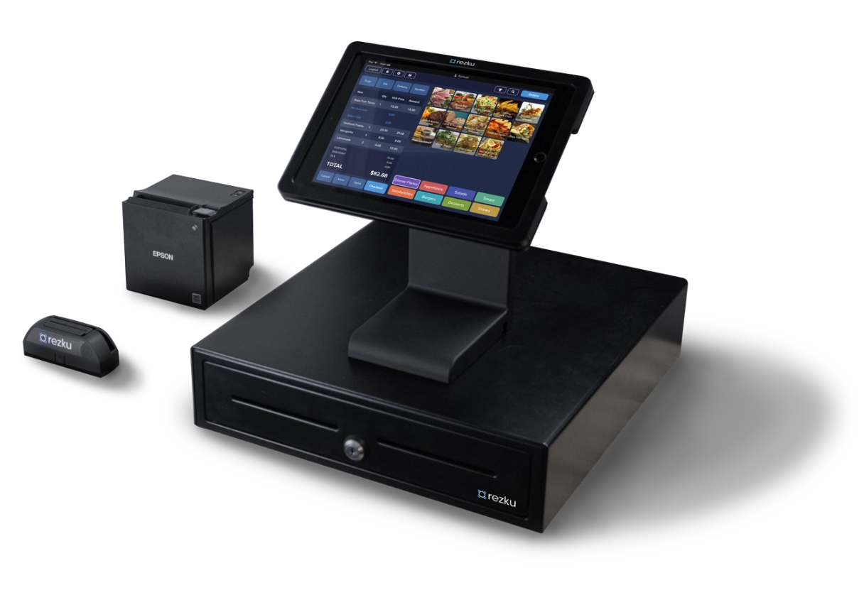

**Rezku System:**

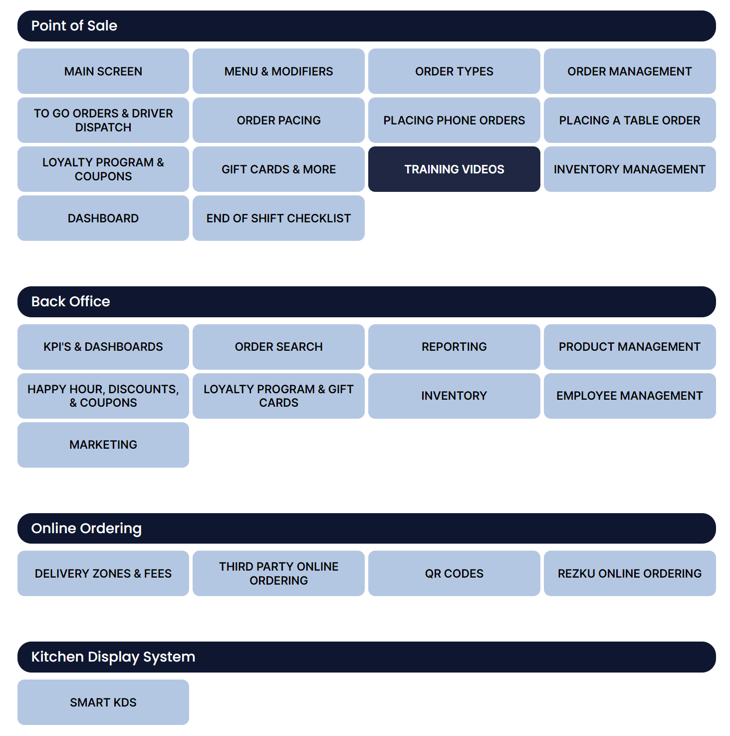

Figure - Rezku System Features.

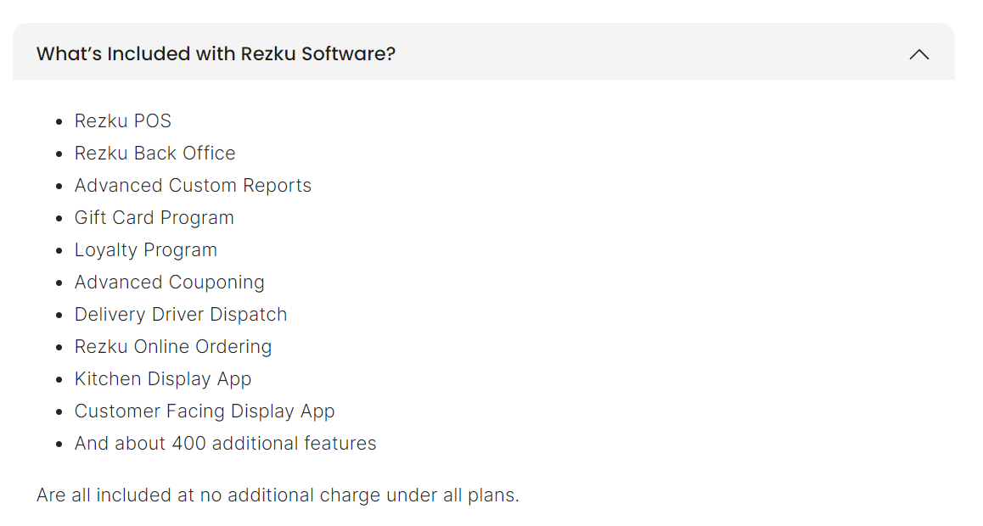

Figure - Features listed from Rezku website.

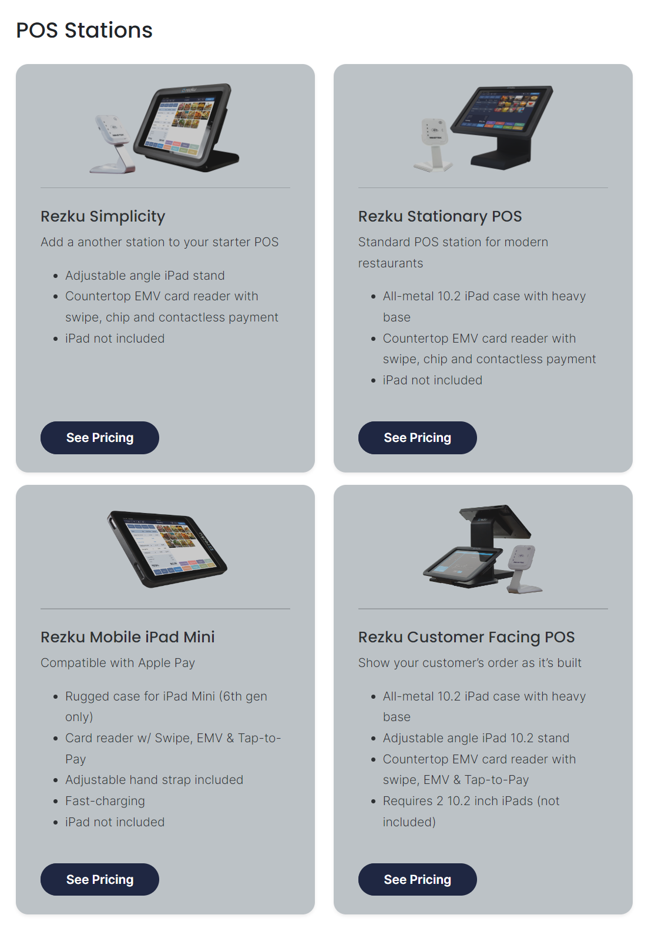

Figure - Hardware provided with services.

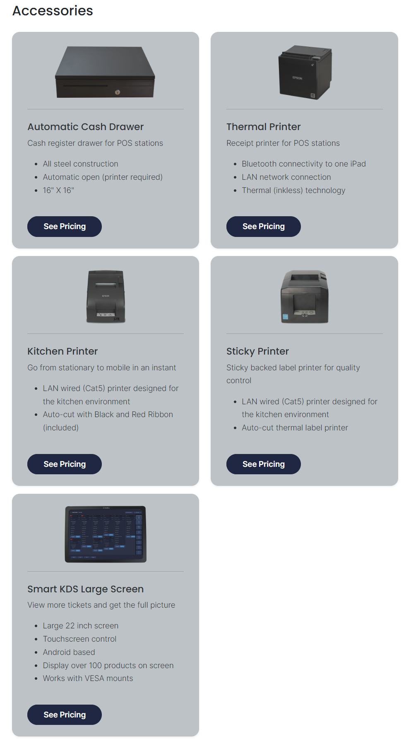

Figure - Accessories for Rezku POS system.

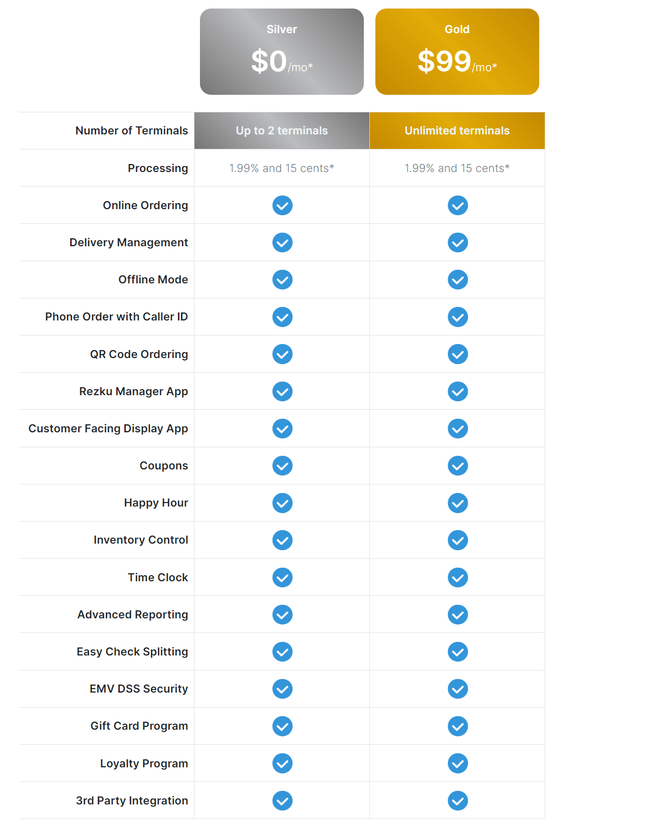

Figure - Service Pricing.

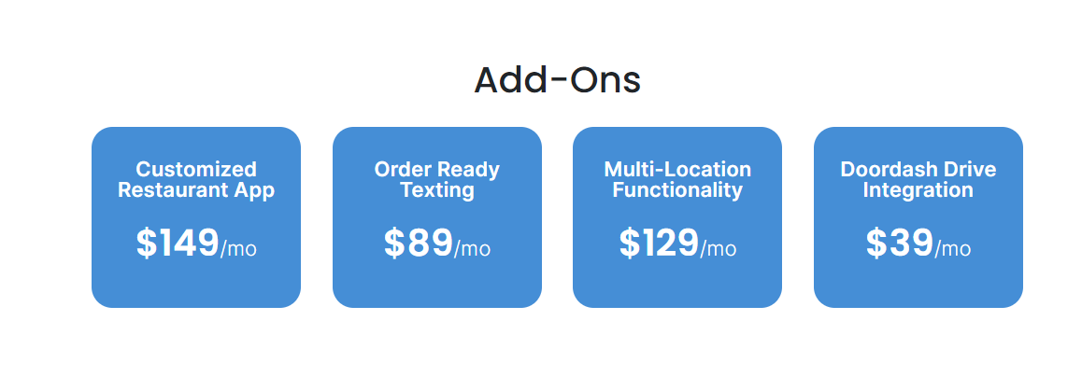

Figure - Add-on Pricing.